|  |
| --- |
|  |

**ZephyrDesk :** Learnings Documentation

**Learnings**

1. Dataverse – While creating columns, follow a standard naming convention for Schema Name. Use small letters and underscore (_) for spacing.

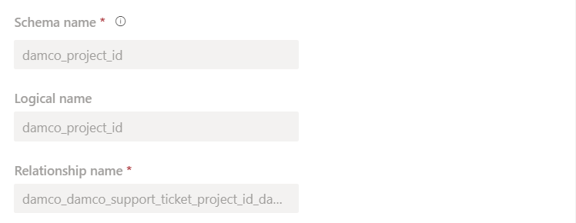

1. Dataverse – While creating a choice type column, always prefix solution name while creating new choices.

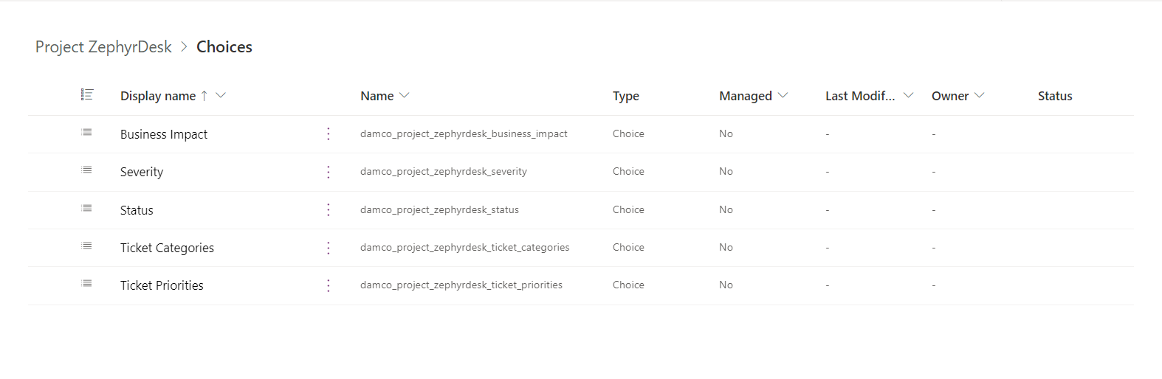

1. Dataverse – Always replace the default values of choices with more accessible values (like 0,1,2,3) for they will be used by/in Power Automate in logic building.

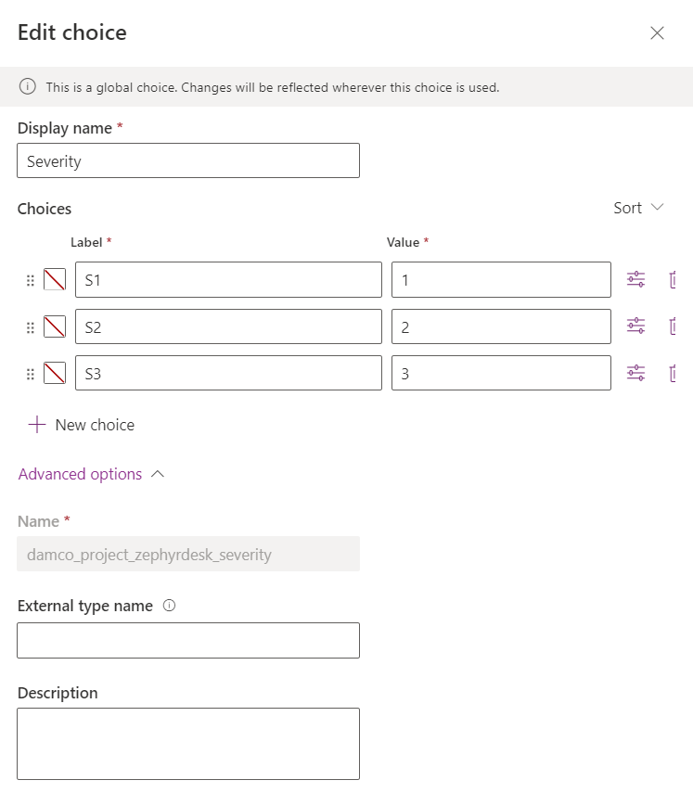

1. Power Automate – MS Forms will send text input even for the choice type fields, so to mitigate errors convert the text values to choices using custom value.

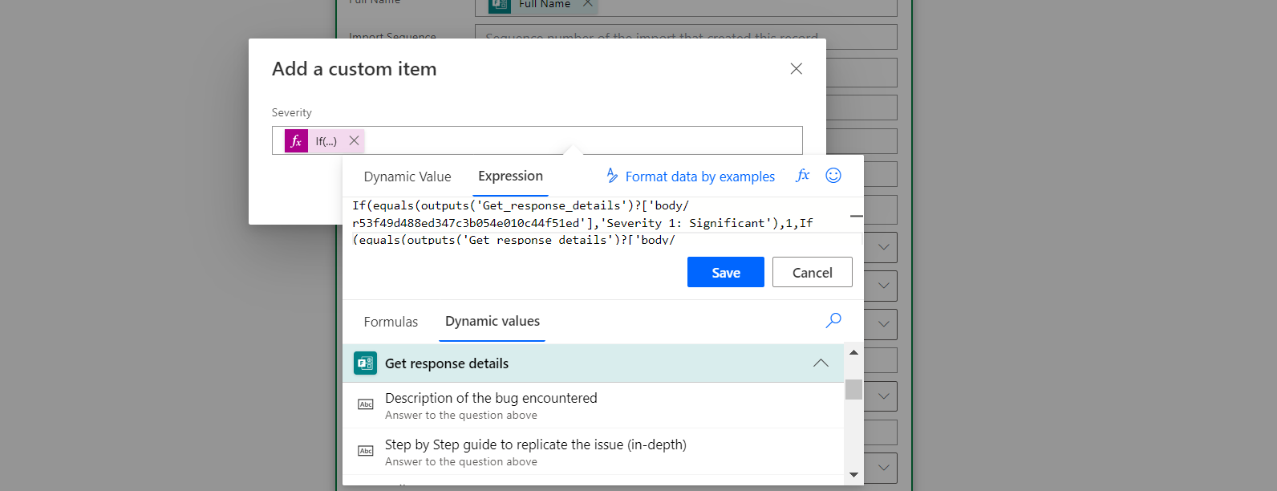

Formula used -

If(equals(outputs('Get_response_details')?['body/r53f49d488ed347c3b054e010c44f51ed'],'Severity 1: Significant'),1,If(equals(outputs('Get_response_details')?['body/r53f49d488ed347c3b054e010c44f51ed'],'Severity 2: Less Significant'),2,3))

1. Model Driven Apps – 2 things create the skeleton of the Model-driven apps.

* Forms

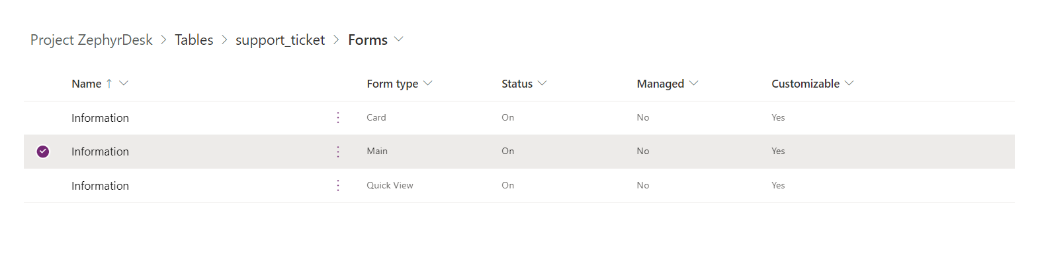

* Views

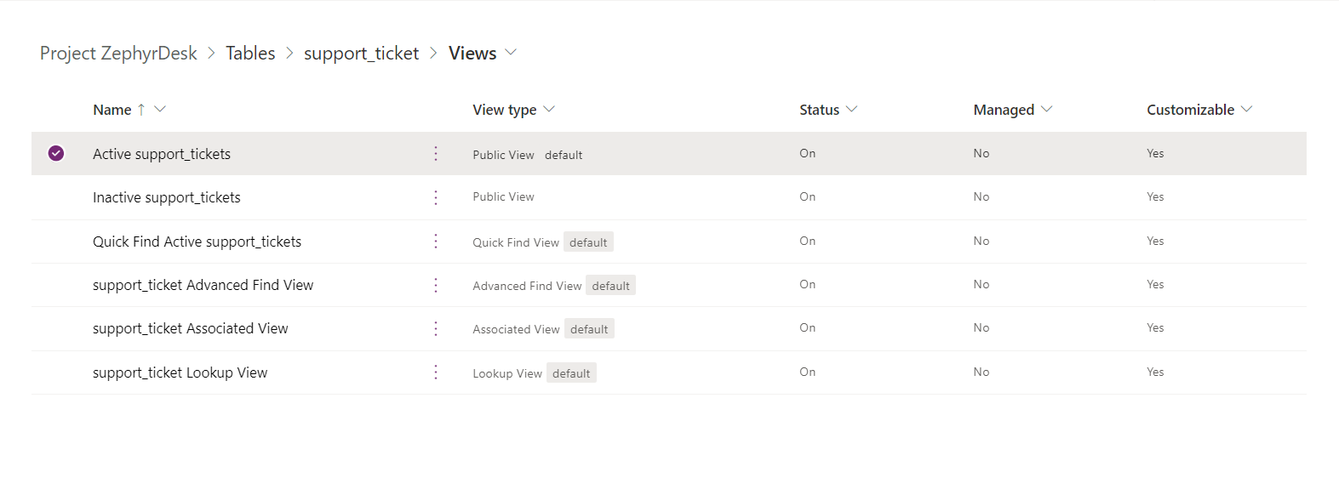

1. To avoid connection reference dependencies issues during ALM process use connection references. Try to avoid personal user connections, use service connections instead.
2. Service connections can only be used for Dataverse connections and not for office 365 or Outlook connection.
3. Sending emails directly through Activities in Model Driven App – Default settings won’t allow the user to send emails unless necessary permissions are given. To give the necessary permission follow the following steps.
4. 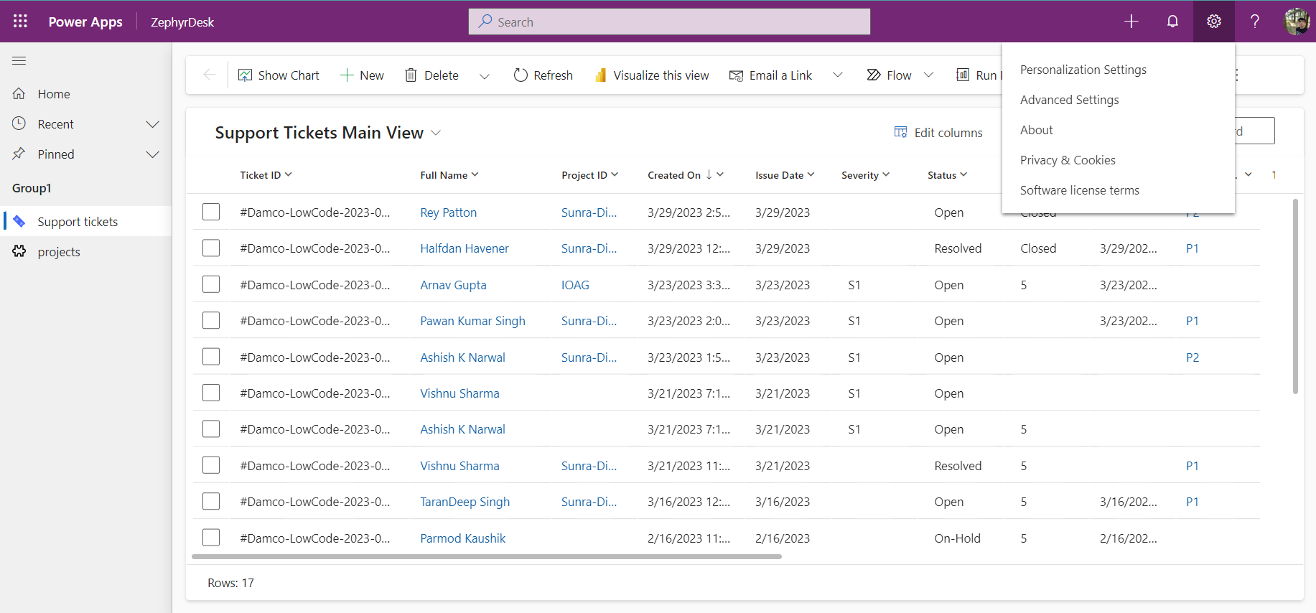

Open the app in Play mode and click on the top right hand corner gear icon. Go to Personalized Settings

1. 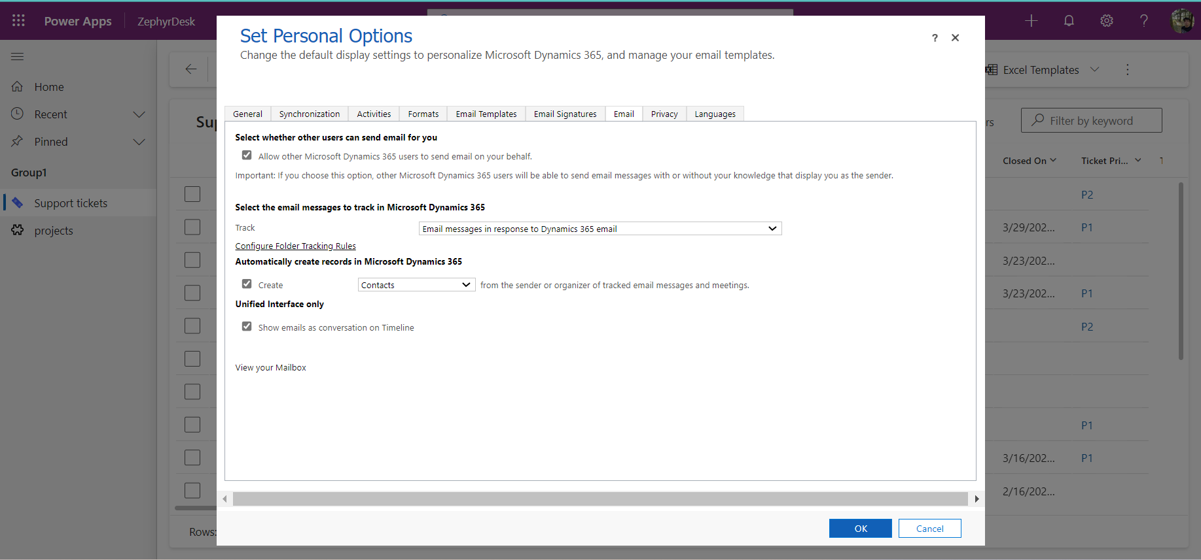

Go to the Email tab in the settings and the check the box which says, “Allow other Microsoft Dynamics 365 users to send email on your behalf.”